Automated HVAC Duct Detection and Annotation Web Application

1. LLD Objective
The purpose of this LLD is to translate the HLD into implementable engineering components for a web application that:
- accepts HVAC drawing PDFs through a browser
- creates a processing job
- runs asynchronous duct detection and annotation
- stores outputs and metadata
- returns annotated preview and downloadable results
The sample indicates the output is a visual markup over the original mechanical plan, so the LLD emphasizes rendering, coordinate mapping, label association, and result serving rather than only raw extraction.

2. Suggested Tech Stack

Frontend
- Next.js or React
- TypeScript
- TanStack Query or SWR
- PDF/image viewer with zoom/pan

Backend
- FastAPI preferred
- Python for tight integration with PDF/CV pipeline
- Pydantic for request/response schemas
- SQLAlchemy for DB ORM

Async Processing
- Celery or RQ
- Redis as broker/cache

Processing Engine
- PyMuPDF
- pdfplumber
- OpenCV
- Shapely
- NumPy
- Pandas

Data/Infra
- PostgreSQL
- S3-compatible object storage
- Docker

3. LLD Scope
This LLD covers:
- frontend pages and UI interactions
- backend API routes and handlers
- queue payloads
- worker lifecycle
- PDF processing modules
- annotation generation modules
- database tables
- storage conventions
- failure handling
- configuration model

4. Component Breakdown
At LLD level, the system is split into the following concrete components:
- Frontend UI
- Auth/Session Layer
- Upload Service
- Job Service
- Result Service
- Admin/Monitoring Service
- Queue Producer
- Worker Runtime
- Processing Pipeline Modules
- Persistence Layer
- Object Storage Layer

5. Frontend LLD

5.1 Pages

Upload Page
Responsibilities:
- select PDF
- validate extension/size
- upload file
- optional page selection
- trigger processing job

Job List Page
Responsibilities:
- show recent jobs
- show statuses
- allow reopen/download

Job Detail Page
Responsibilities:
- show file metadata
- show progress/status
- show error state if failed
- show result preview if completed

Result Viewer
Responsibilities:
- image/PDF preview
- zoom/pan
- overlay metadata panel
- segment list sidebar

Admin Dashboard
Responsibilities:
- failed jobs
- worker errors
- logs
- system health summary

5.2 Frontend Component Diagram

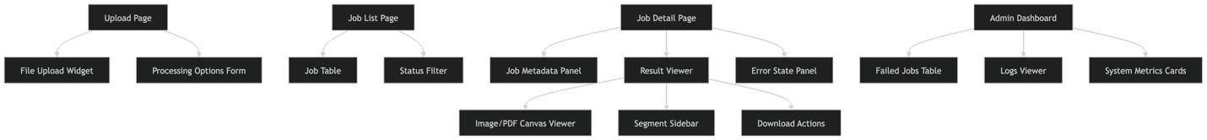

6. Backend Service LLD

6.1 Service Modules

upload_service
Responsibilities:
- validate file
- create storage object key
- upload original file
- create DB file record

job_service
Responsibilities:
- create job
- validate page selection
- enqueue worker payload
- update status

result_service
Responsibilities:
- fetch outputs
- build preview response
- build segment summaries
- generate download URLs

admin_service
Responsibilities:
- fetch failed jobs
- fetch logs
- inspect worker outcomes

auth_service
Responsibilities:
- session validation
- access control
- user scoping
6.2 Backend Internal Flow Diagram

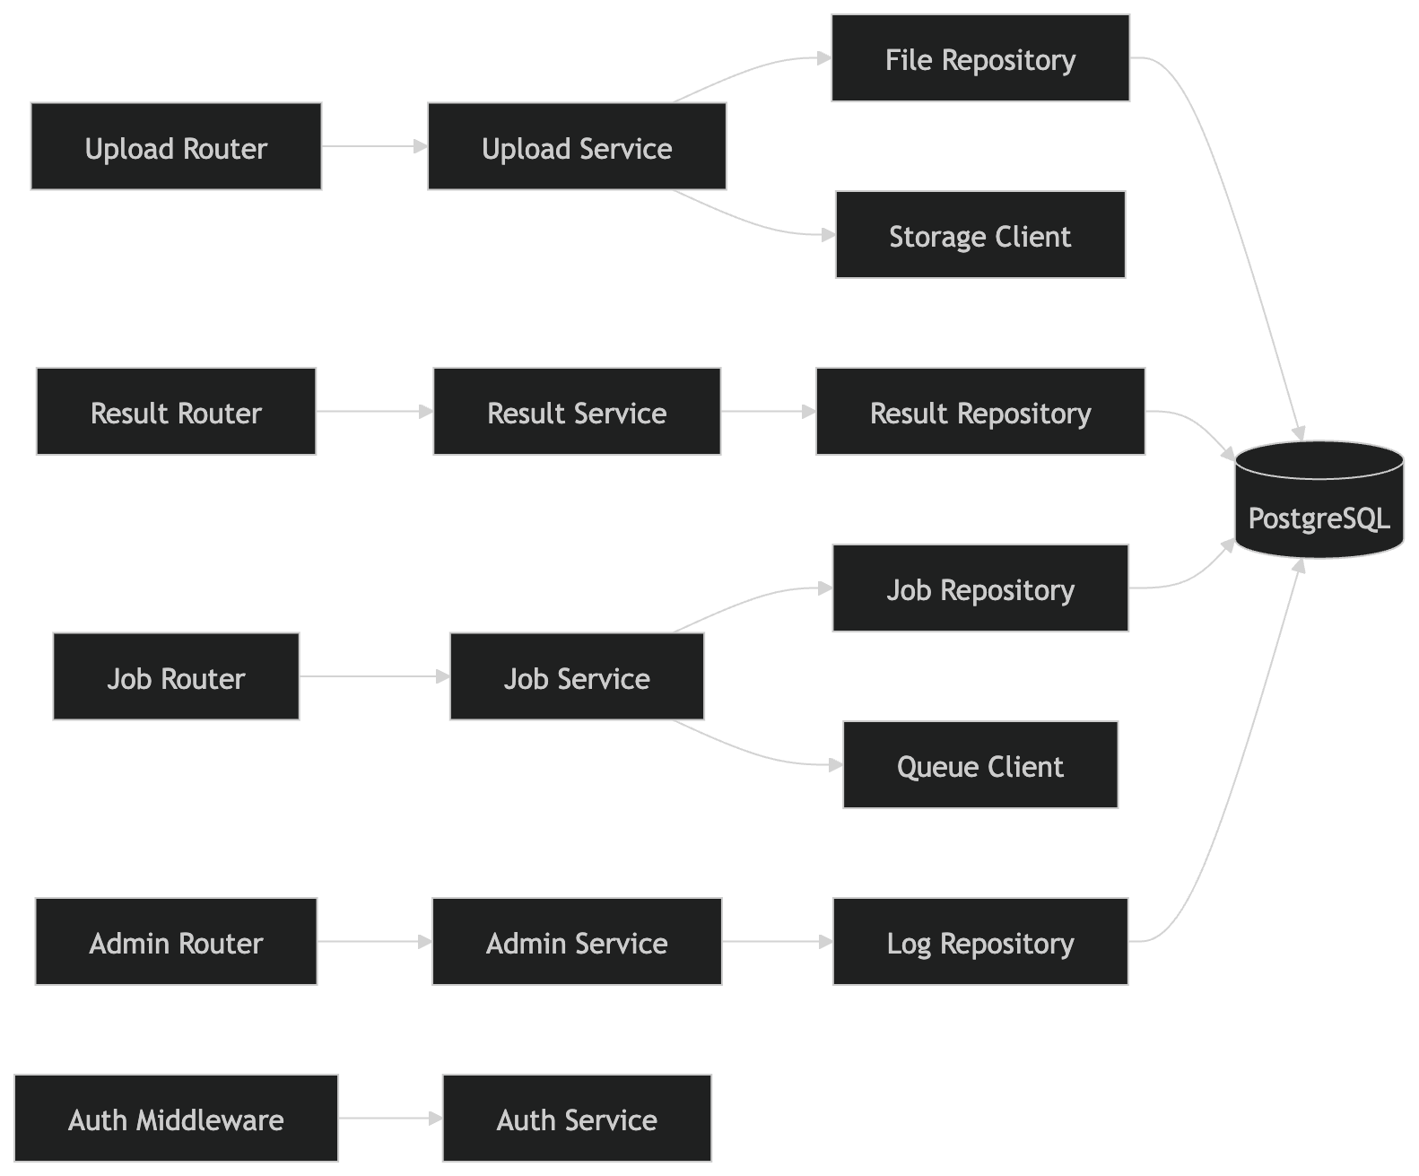

7. API LLD

7.1 Upload API

POST /api/files/upload

Request
- multipart form-data
- fields:
  - file
  - page_selection_mode optional
  - page_numbers optional

Response
{
"fileId": "file_123",
"fileName": "testset2.pdf",
"status": "uploaded",
"pageCount": 1
}

Validation
- only PDF
- size threshold
- checksum optional
- virus scan optional in production

7.2 Job Creation API

POST /api/jobs

Request
{
"fileId": "file_123",
"pageSelectionMode": "all",
"pageNumbers": [],
"outputFormats": ["png", "pdf", "json"]
}

Response
{
"jobId": "job_456",
"status": "queued"
}

7.3 Job Status API

GET /api/jobs/{jobId}

Response
{
"jobId": "job_456",
"fileId": "file_123",
"status": "processing",
"progress": 65,
"step": "label_association",
"createdAt": "2026-04-24T10:30:00Z",
"updatedAt": "2026-04-24T10:31:10Z"
}

7.4 Result API

GET /api/jobs/{jobId}/result

Response
{
"jobId": "job_456",
"status": "completed",
"previewUrl": "/files/output/job_456/annotated.png",
"annotatedPdfUrl": "/files/output/job_456/annotated.pdf",
"exports": {
"json": "/files/output/job_456/segments.json",
"csv": "/files/output/job_456/segments.csv"
},
"summary": {
"pagesProcessed": 1,
"segmentsDetected": 23,
"segmentsMeasured": 19,
"labelsMatched": 18
}
}

7.5 Segments API

GET /api/jobs/{jobId}/segments

Response
{
"segments": [
{
"segmentId": "D-001",
"pageNumber": 1,
"type": "supply",
"shape": "rectangular",
"sizeText": "12x8",
"lengthFt": 14.5,
"confidence": 0.91,
"bbox": [100, 120, 300, 150]
}
]
}

7.6 Admin APIs
- GET /api/admin/jobs
- GET /api/admin/jobs/{jobId}/logs
- GET /api/admin/metrics
8. API Sequence LLD

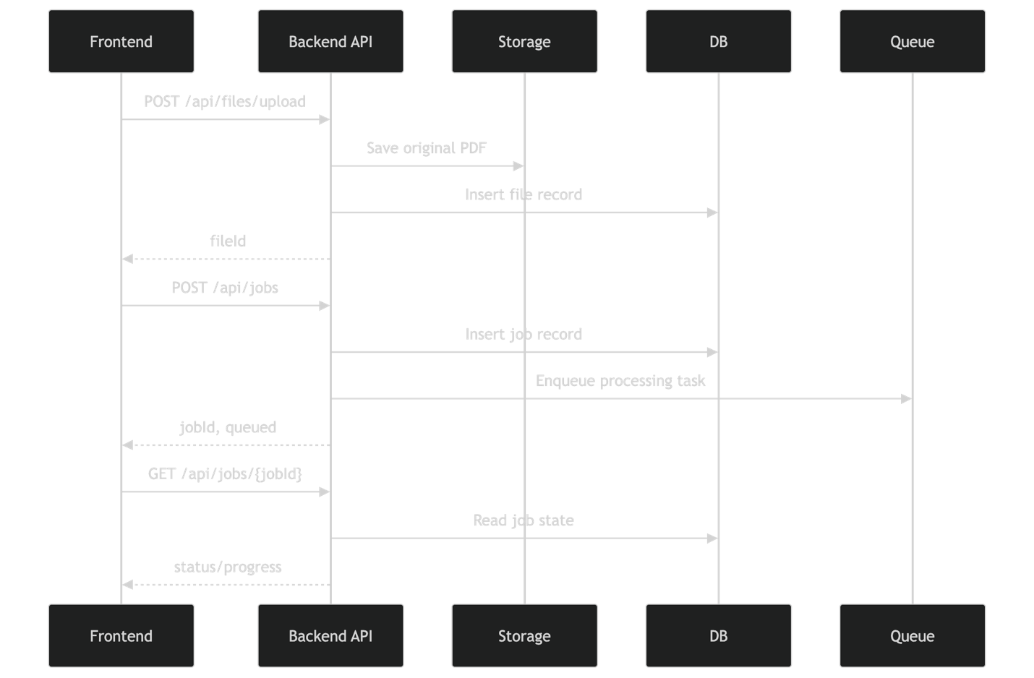

9. Database LLD

9.1 Core Tables

users
- id
- email
- name
- role
- created_at

files
- id
- user_id
- original_name
- storage_key
- mime_type
- size_bytes
- checksum
- page_count
- created_at

jobs
- id
- user_id
- file_id
- status
- progress_percent
- current_step
- error_code
- error_message
- created_at
- updated_at
- completed_at

job_pages
- id
- job_id
- page_number
- status
- rendered_image_key
- plan_crop_bbox
- scale_text
- scale_factor
- created_at

duct_segments
- id
- job_id
- page_number
- segment_code
- segment_type
- shape
- size_text
- width_value
- height_value
- diameter_value
- length_value
- length_unit
- confidence_score
- bbox_json
- polyline_json
- created_at

job_outputs
- id
- job_id
- output_type
- storage_key
- mime_type
- created_at

job_logs
- id
- job_id
- level
- step
- message
- payload_json
- created_at

9.2 ER Diagram

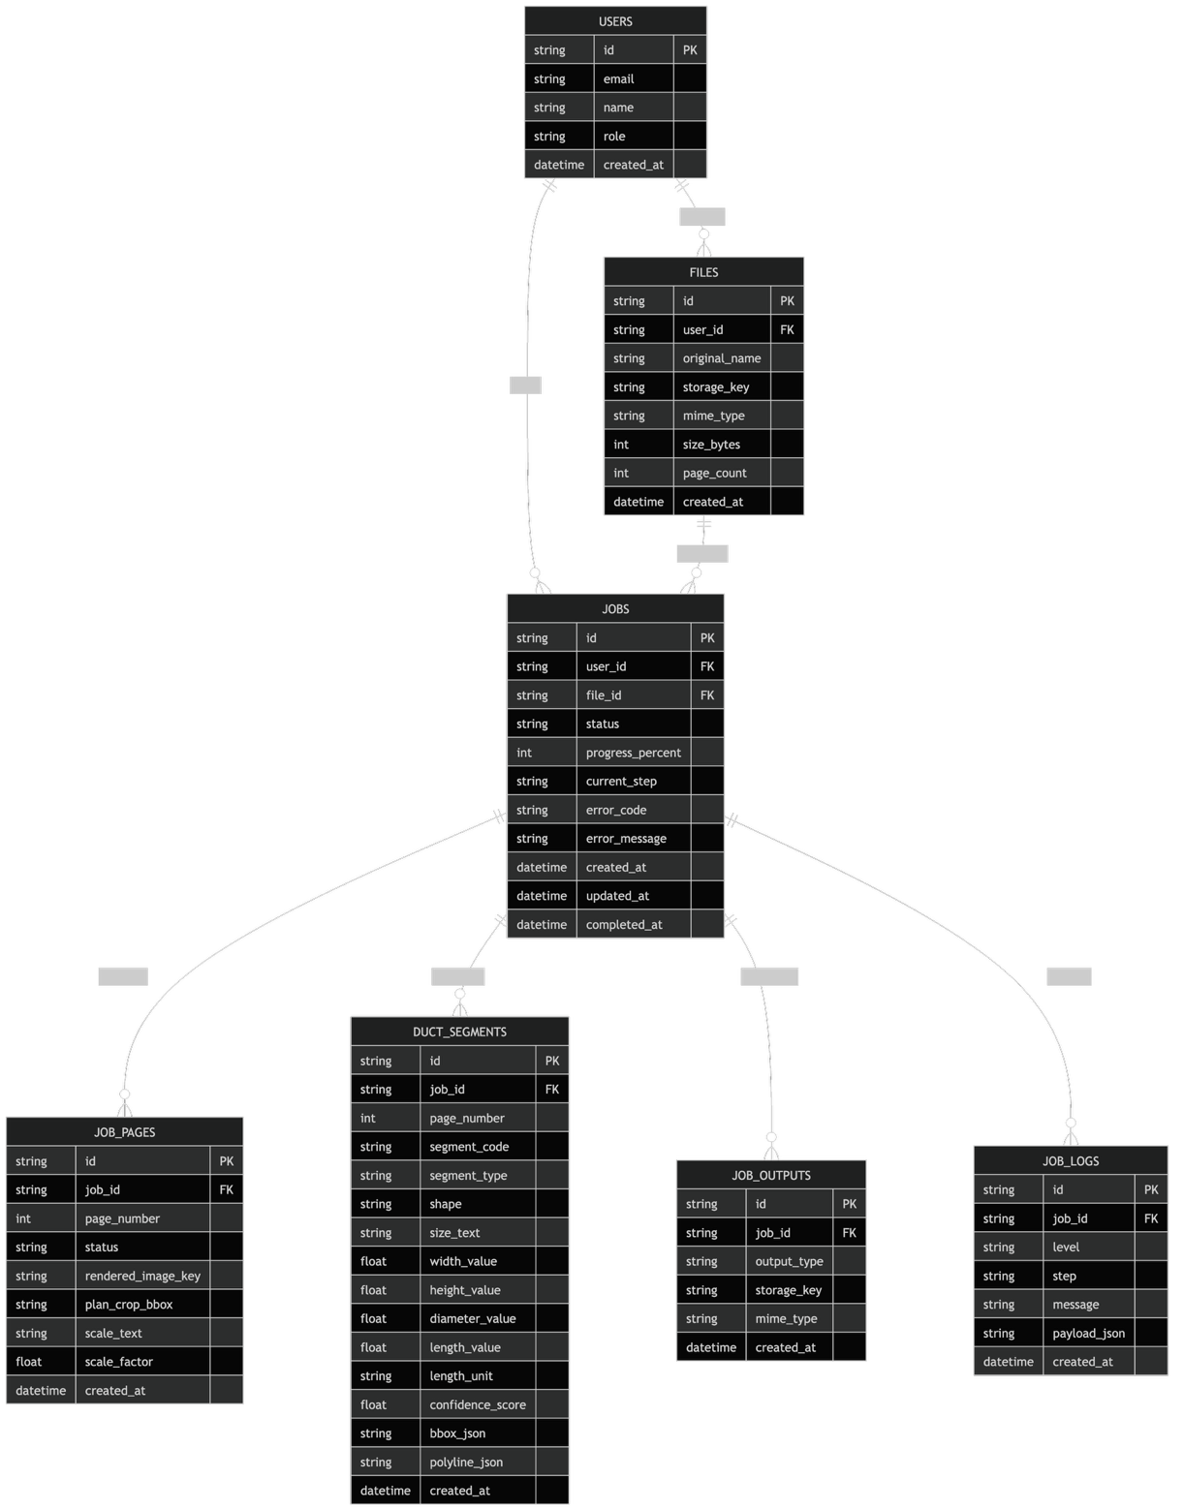

10. Queue and Worker LLD

10.1 Queue Payload
{
"jobId": "job_456",
"fileId": "file_123",
"userId": "user_789",
"storageKey": "inputs/2026/04/testset2.pdf",
"pageSelectionMode": "all",
"pageNumbers": [],
"outputFormats": ["png", "pdf", "json"],
"requestedAt": "2026-04-24T10:30:00Z"
}

10.2 Worker Lifecycle
- dequeue job
- mark job as processing
- download PDF from storage
- iterate pages
- run processing pipeline
- store outputs
- persist segments/metadata
- mark job completed
- on failure, mark failed and store logs

10.3 Worker State Diagram

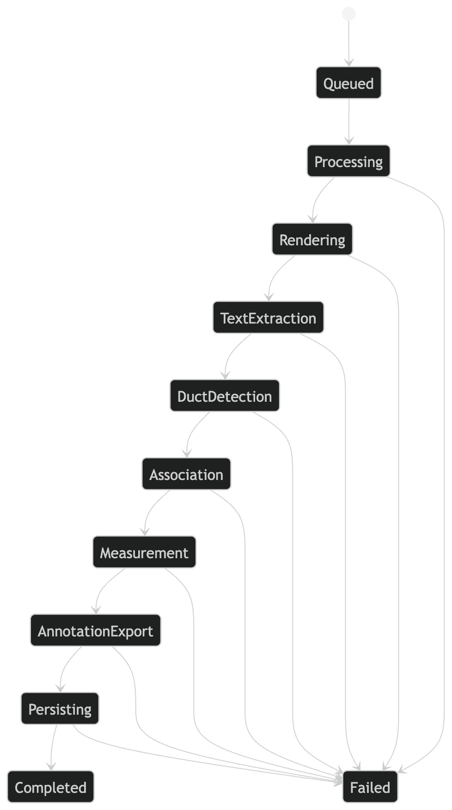

11. Processing Engine LLD
This is the most important section.

11.1 Pipeline Modules

A. pdf_loader.py
Responsibilities:
- open PDF
- validate file readability
- count pages
- extract page dimensions

B. renderer.py
Responsibilities:
- render page at configurable DPI
- create raster image
- preserve transform mapping between PDF coordinates and image coordinates

C. plan_region_detector.py
Responsibilities:
- detect main plan drawing area
- suppress title block, notes, legends
- compute crop box

D. text_extractor.py
Responsibilities:
- extract words/phrases with coordinates
- merge nearby text tokens
- keep source coordinates

E. dimension_parser.py
Responsibilities:
- regex-based parsing of duct sizes
- parse rectangular and circular labels
- normalize units

F. duct_detector.py
Responsibilities:
- detect likely duct geometry from rendered plan
- find corridors/runs
- detect branches and elbows
- create raw duct candidates

G. segment_builder.py
Responsibilities:
- merge and split duct candidates
- produce duct segments
- assign local IDs

H. association_engine.py
Responsibilities:
- score candidate text labels against segments
- choose best label match
- attach confidence score

I. scale_detector.py
Responsibilities:
- detect explicit drawing scale text
- compute pixel/image to real-world conversion
- fallback to manual or configured scale

J. measurement_engine.py
Responsibilities:
- compute segment lengths
- apply unit conversion
- round output values

K. annotation_renderer.py
Responsibilities:
- draw highlighted ducts
- draw labels and IDs
- create final annotated page image/PDF

L. exporter.py
Responsibilities:
- export JSON/CSV
- write summaries
- produce manifest metadata

11.2 Processing Module Diagram

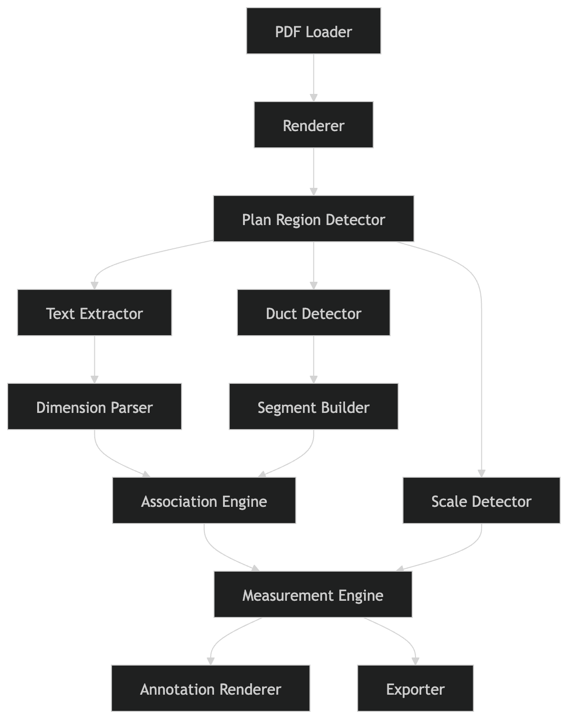

12. Internal Data Contracts

12.1 Page Context
{
"pageNumber": 1,
"pdfWidth": 1440,
"pdfHeight": 900,
"renderedWidth": 2880,
"renderedHeight": 1800,
"dpi": 300,
"transform": {
"scaleX": 2.0,
"scaleY": 2.0
}
}

12.2 Text Block
{
"text": "12x8",
"bbox": [210, 430, 260, 455],
"pageNumber": 1,
"source": "pdf_text",
"rotation": 0
}

12.3 Duct Candidate
{
"candidateId": "cand_01",
"pageNumber": 1,
"polyline": [[100, 100], [250, 100], [250, 180]],
"bbox": [100, 90, 260, 190],
"orientation": "mixed",
"rawConfidence": 0.84
}

12.4 Segment Model
{
"segmentId": "D-001",
"pageNumber": 1,
"polyline": [[100, 100], [250, 100]],
"bbox": [100, 90, 250, 110],
"shape": "rectangular",
"type": "supply",
"sizeText": "12x8",
"lengthValue": 14.5,
"lengthUnit": "ft",
"confidence": 0.91
}

13. Label Association Logic

13.1 Inputs
- segment geometry
- nearby text blocks
- dimension-parsed text blocks

13.2 Scoring Factors
- distance from segment centerline
- parallel orientation
- HVAC size pattern confidence
- collision with unrelated geometry
- text placement in duct corridor
- symbol proximity if present

13.3 Output
- best matched label per segment
- confidence score
- unmatched labels list

13.4 Association Flow Diagram

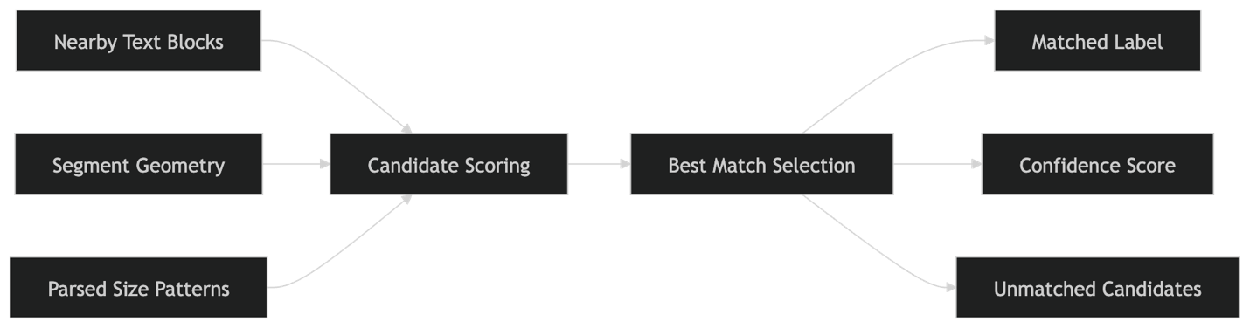

14. Measurement Engine LLD

14.1 Measurement Logic
The system measures along the segment polyline.
Formula:
- pixel length from polyline
- convert to drawing units using page transform
- convert drawing units to real units using scale factor
- round using configured precision

14.2 Measurement Modes
- centerline
- straight_run
- annotation_override
Default:
- centerline

14.3 Rounding Rules
- feet: 2 decimals or feet-inch string
- metric: 1 or 2 decimals
15. Annotation Renderer LLD

15.1 Responsibilities
- draw duct paths
- draw outline/highlight
- draw label boxes
- avoid label collisions where possible
- preserve readability

15.2 Output Artifacts
- annotated PNG per page
- annotated PDF full document
- optional debug images

15.3 Styling Rules
- supply ducts: blue
- return ducts: orange
- uncertain detections: dashed red
- label text: dark text on white box

15.4 Renderer Flow

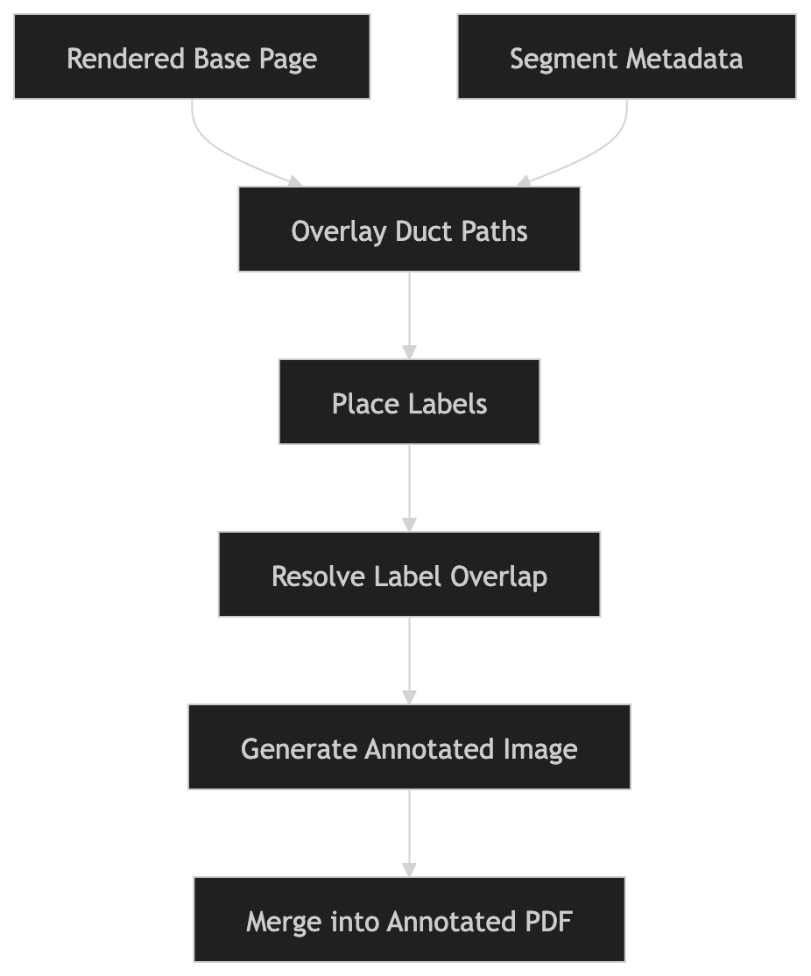

16. Storage Key Conventions

Input
inputs/{year}/{month}/{fileId}/original.pdf

Intermediate
jobs/{jobId}/pages/{pageNumber}/rendered.png
jobs/{jobId}/pages/{pageNumber}/plan_crop.png
jobs/{jobId}/pages/{pageNumber}/debug_overlay.png

Outputs
jobs/{jobId}/outputs/annotated.png
jobs/{jobId}/outputs/annotated.pdf
jobs/{jobId}/outputs/segments.json
jobs/{jobId}/outputs/segments.csv
jobs/{jobId}/outputs/manifest.json

17. Suggested Code Structure
backend/
├── app/
│ ├── main.py
│ ├── api/
│ │ ├── upload_routes.py
│ │ ├── job_routes.py
│ │ ├── result_routes.py
│ │ └── admin_routes.py
│ ├── core/
│ │ ├── config.py
│ │ ├── auth.py
│ │ └── logging.py
│ ├── services/
│ │ ├── upload_service.py
│ │ ├── job_service.py
│ │ ├── result_service.py
│ │ └── admin_service.py
│ ├── repositories/
│ │ ├── file_repository.py
│ │ ├── job_repository.py
│ │ ├── segment_repository.py
│ │ ├── output_repository.py
│ │ └── log_repository.py
│ ├── workers/
│ │ ├── queue_client.py
│ │ ├── task_runner.py
│ │ └── job_processor.py
│ ├── processing/
│ │ ├── pdf_loader.py
│ │ ├── renderer.py
│ │ ├── plan_region_detector.py
│ │ ├── text_extractor.py
│ │ ├── dimension_parser.py
│ │ ├── duct_detector.py
│ │ ├── segment_builder.py
│ │ ├── association_engine.py
│ │ ├── scale_detector.py
│ │ ├── measurement_engine.py
│ │ ├── annotation_renderer.py
│ │ └── exporter.py
│ ├── models/
│ │ ├── file.py
│ │ ├── job.py
│ │ ├── job_page.py
│ │ ├── duct_segment.py
│ │ ├── job_output.py
│ │ └── job_log.py
│ └── schemas/
│ ├── upload.py
│ ├── job.py
│ ├── result.py
│ └── segment.py
frontend/
├── src/
│ ├── pages/
│ ├── components/
│ ├── hooks/
│ ├── services/
│ └── types/

18. Error Handling LLD

18.1 API Errors
Standard shape:
{
"error": {
"code": "INVALID_FILE_TYPE",
"message": "Only PDF files are supported."
}
}

18.2 Job Failure Categories
- invalid_pdf
- password_protected_pdf
- render_failed
- text_extraction_failed
- duct_detection_failed
- storage_write_failed
- unexpected_internal_error

18.3 Retry Policy
- retry storage/network failures
- do not retry malformed PDFs automatically
- record per-stage failure logs

19. Security and Access Control LLD

Rules
- user can access only own files/jobs/results
- admin can access all jobs/logs
- signed URLs for download where applicable
- file upload size limits
- MIME and extension validation
- sanitize log payloads

20. Config Model
Example configurable values:
app:
max_upload_size_mb: 100
default_output_formats: ["png", "pdf", "json"]
processing:
render_dpi: 300
measurement_mode: "centerline"
min_segment_length_px: 15
low_confidence_threshold: 0.5
annotation:
show_segment_ids: true
show_length: true
show_size: true
storage:
signed_url_expiry_minutes: 60

21. End-to-End LLD Flow

22. Implementation Priorities

Phase 1
- upload
- create job
- render page
- detect plan region
- detect ducts
- draw visual overlay
- return annotated PNG

Phase 2
- text extraction
- dimension parsing
- label association
- structured JSON output

Phase 3
- PDF export
- segment sidebar
- admin monitoring
- confidence/debug artifacts

Phase 4
- manual correction UI
- advanced shape support
- multi-user workspace features

23. LLD Summary
This LLD defines the implementable design for a web-based asynchronous HVAC duct annotation platform with:
- browser upload and result viewing
- API-driven job orchestration
- queue-based worker processing
- modular PDF/CV pipeline
- structured database persistence
- output artifact generation
- admin and failure observability
It is designed to match the actual problem behavior: a PDF input and a visually annotated duct-highlighted output, with optional structured metadata.

